Components Document

Author: William Kerr

Table of Contents

Solar panels
Charge Controller
Batteries
Battery Management System
Sensors – Faculty
Faculty Micro controller
Sensors – Student
Student Micro controller
Heater – Battery pack
Cooler – Battery pack
AC outlet
GSM module
SIM card
Web Server

Solar Panels:

Explanation:

This is a client request.

These solar panels let certain wavelengths of light through them, and absorb the rest of the spectrum.
This allows plants to grow inside.

Model: LUMO 20M100GH
Quantity: 24x
Company: Soliculture
Company Website: http://www.soliculture.com/
Product Page: http://www.soliculture.com/product/

Datasheet:
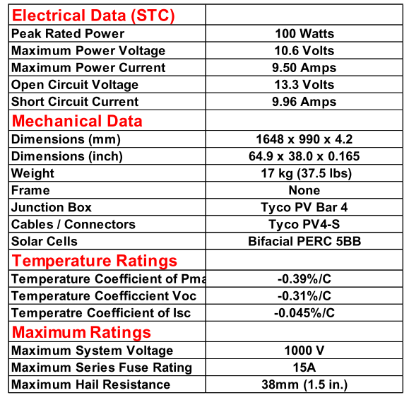

Charge Controller:

Explanation:

Solar panels cannot charge batteries directly. 1.) They have unstable voltages, and thus should not be connected directly to the battery. 2.) Batteries with different chemical compositions charge differently. Solar panels do not charge them properly. We must have a charge controller. I like this one since it is not only custom-programmable, you can get a significant amount of data from it.

Model: MORNINGSTAR TS-MPPT-60 TriStar MPPT 150V
Company: Morningstar
Company Website: https://www.morningstarcorp.com
Product link: https://www.morningstarcorp.com/products/tristar-mppt/
Quantity: 2x

Features:

Customizable Charge Settings
Great networking capabilities
RS-232 electrical interface for Microcontroller communication.
Uses royalty-free MODBUS protocol for easy data harvesting
Operating Range: -40C to 40C
Up to 60A continuous battery current
Compatible with 12V, 24V, and 48V battery systems
Maximum 150V solar panels in series
Keyholes for mounting
Uses TrakStar MPPT technology to track the maximum power point of the solar panels.
Temperature compensation

Tristar Morningstar MPPT can monitor:

From the internal ADC chips:

Battery Voltage
Battery Terminal Voltage
Battery Sense Voltage
Array Voltage (of the solar panels)
Battery Current
Array Current (of the solar panels),
12V supply,
3V supply,
meterbus voltage,
1.8V supply,
Reference voltage

Temperature Data:

Heatsink Temperature
RTS temperature
Battery Regulation Temperature

Status Data:

Battery Voltage (slow)
Charging Current (slow)
Minimum Battery Voltage
Maximum Battery Voltage
Hourmeter
Faults raised
Alarms raised
LED state
DIP switch status

MPPT Data:

Output Power
Input Power
Max power of last sweep
Vmp of last sweep
Voc of last sweep

Charger Data:

Charge state
Target Regulation Voltage
Ah charge resettable:
Ah charge total
kWhr charge resettable
kWhr charge total

Daily Data:

Battery Voltage Minimum
Battery Voltage Maximum
Input Voltage Maximum
Amp Hours accumulated
Watt hours accumulated
Minimum Power output
Minimum temperature
Maximum temperature
Time in ab stage
Time in equalize stage
Time in float stage
Alarms of the day
Faults of the day
Flags of the day

Current Charge Settings:
EV_absorp
EV_float
Et_absorp
Et_absorp_ext
EV_absorp_ext
EV_float_cancel
Et_float_exit_cum
EV_eq
Et_eqcalendar
Et_eq_above
Et_eq_reg
Et_battery_service
EV_tempcomp
EV_hvd
EV_hvr
Evb_ref_lim
ETb_max
Etb_min
Elb_lim
EVa_ref_fixed_init
EVa_ref_fixed_pet_init

LED settings

EV_soc_g_gy
EV_soc_gy_y
EV_soc_y_yr
EV_soc_yr_r

Recommended Accessories:

Remote Temperature Sensor

Explanation:

The greenhouse naturally changes temperature more than 5 C during the year. The Morningstar Corporation recommends that you add the RTS sensor for the Charge Controller to operate more effectively.

Model: Remote Temperature Sensor
Quantity: 2x
Company: Morningstar
Company Website: https://www.morningstarcorp.com/
Product Page: https://www.morningstarcorp.com/products/remote-temperature-sensor/

RS-232 to USB cable

Explanation:
RS-232 must be converted to USB format for easy monitoring by the Raspberry Pi. Luckily, I don’t have to reinvent the wheel. I can simply use this cable.

RS-232 Male to USB male

Model: C2G 26886 USB to DB9 Serial RS232 Adapter Cable, Blue (1.5 Feet, 0.45 Meters)
Quantity: 2x
Company: C2G
Company Website: https://www.cablestogo.com/
Product Page: https://www.amazon.com/C2G-Cables-26886-Serial-Adapter/dp/B000067RVJ

Batteries:

Lithium-ion Battery Cell

Explanation:

Solar panels do not produce power all the time. Even when they do produce power, they often don’t produce enough power to satisfy the consumer. During the day, when the solar panels produce the most power, the consumer often isn’t using the system. To resolve this, we need to have a battery pack. During the day, the battery pack will be charged by the solar panels, and during the evening, the battery pack will be discharged by the consumer.

Model: IFP71/180/278-CA180FI
Quantity: 8
Company: CALB
Company website: http://www.calbusainc.com/
Product Page: https://www.ev-power.eu/LiFePO4-small-cells/Prismatic/CALB-CA180FI-Lithium-Cell-LiFePO4-3-2V-180Ah.html

Datasheet:
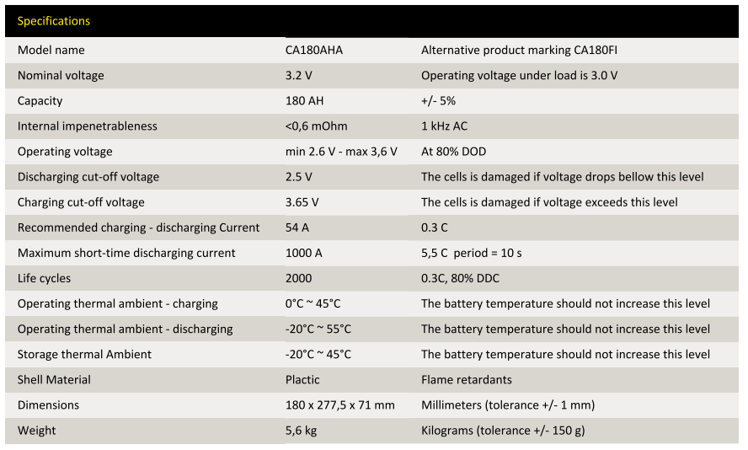
Battery Management System:

Explanation:

Batteries don’t discharge evenly. Every battery has its own individual chemistry due to imperfections in the manufacturing process. If we discharge batteries unevenly, one battery could be worn out while another battery remains untouched. To resolve this, we use a Battery Management System.

Model: G1 EMUS BMS control unit
Quantity: 1
Company: Emus
Company Website: https://emusbms.com/
Product Page: https://emusbms.com/product/g1-bms-control-unit

Features:

Automatically controls the battery operation process utilizing various interfaces for measurement, control, data exchange, configuration and indication.
Works with any charge controller
Application:
Any lithium chemistry, series connected battery pack of up to 254 cells if using serial cell communication
Any lithium chemistry, series connected battery pack, or pack of multiple parallel strings, up to 8128 cells total, if using EMUS CAN Cell Group Modules.
Storage Temperature: -40 C to 95 C
Operation Temperature: -40 C to 80 C
USB interface for Microcontroller reading
Proprietary serial interface for cell communication

BMS control unit can monitor:

From the system as a whole:

Battery Charge
Charger Status
Current and Voltage
Distance and Energy (if applied to an electric vehicle)
BMS status
Time and Date
Version Number

From each individual cell and from the system as a whole:

Battery Balancing Rate
Temperature
Battery Voltage

Has an internal events log (each event happening at a recorded time)

Has a statistics log at a recorded time. Possible statistics to log:
- Total Discharge
- Total Charge
- Total Discharge Energy
- Total Charge Energy
- Total Discharge Time
- Total Charge Time
- Total Distance
- Max Discharge Current
- Max Charge Current
- Min Cell Voltage
- Max Cell Voltage
- Max cell Voltage Difference
- Min pack voltage
- Max pack voltage
- Min Cell Module Temperature
- Max Cell Module Temperature
- Max Cell Module Temperature Difference
- Protection Counts (undervoltage, overvoltage, discharge overcurrent, charge overcurrent, cell module overheat, leakage protection, no cell communication, low voltage power reduction, high current power reduction, high cell module temperature power reduction, charger connect, charger disconnect, cell overheat, high cell module temperature power reduction)
- Miscellaneous counts (# of Preheat stages, Precharge stages, main charge stages, balancing stages, charging finished stages, charging errors, charging retries, trips, charge restarts)
- Min Cell Temperature
- Max Cell Temperature
- Max Cell Temperature Difference

Necessary Accessories:

Cell Isolators

The BMS system requires that you have isolators to protect the main module.

Only works if only 1 group of batteries is used.

Model: G1 Top/Bottom Isolator
Company Website: https://emusbms.com/
Product Page: https://emusbms.com/product/g1-top-bot-isolator
Quantity: 2x

Cell Modules

Every battery must have its own cell module.
Different batteries require different cell modules.
You can find all types of cell modules here:

https://emusbms.com/product-category/cell_modules

The standard solution is the A/B type, so that’s what we’re going with.
We must order this package for each battery.

EMUS BMS Cell Module A – 1x
EMUS BMS Cell Module B – 1x
Ring Terminal M8 – 2x
Communication Cable – 16cm – 2x

Ordering details:

Model: G1 Cell Module – A/B type
Company: Emus
Company Website: https://emusbms.com
Product Page: https://emusbms.com/product/g1-cell-module-ab
Quantity: 8x

CAN Cell Group Module

We need to group batteries into groups.
Since the batteries we picked are 3.2V, we group batteries into groups of 4.

Model: G1 CAN Cell Group Module
Company: Emus
Company Website: https://emusbms.com/
Product Page: https://emusbms.com/product/g1-can-cell-group-module
Quantity: 2x

Recommended Accessories:

Current Sensor

In order to monitor current dispensing from the batteries to the load, you must have a current sensor. It’s not necessary for operation, but it’s recommended to have one. This one works using the hall effect, so it does not require contact with the wires; it only needs to have the wire running through its hole.

Model: G1 Loop Style Dual Range Current Sensor
Company: Emus
Company Website: https://emusbms.com/
Product Page: https://emusbms.com/product/g1-loop-style-dual-range-current-sensor
Quantity: 1x

Sensors – Faculty

Explanation:

The client wants their own sensors exclusive for faculty. They want to measure temperature, humidity, and light. I propose that we use two classes of sensors for this: a Temperature and Humidity Sensor, and a

The product page and the datasheet are different pages because I want to purchase a whole breakout board instead of homebrewing my own board for it. It’s easier to have a breakout board, and easier to order a new breakout board from ADAFRUIT than it would be to order a PCB, and solder the components onto it.

Temperature and Humidity Sensor:

Model: BME280
Company: Bosch
Company Website: https://bosch.us/
Product Page: https://www.adafruit.com/product/2652
Datasheet: https://cdn-shop.adafruit.com/product-files/2652/2652.pdf

Details:
+-3% accuracy for humidity
+-1% accuracy for temperature
1s response time maximum
Operating range: -40C to 85C
I2C interface
Also can measure pressure if necessary

Light Sensor:

Model: VEML7700
Quantity: 2
Company: Vishay Semiconductors:
Company Website:
Product Page: https://www.adafruit.com/product/4162?gclid=EAIaIQobChMIyOmfve7Q4wIV6f_jBx07fQ1yEAQYASABEgJti_D_BwE
Datasheet: https://www.vishay.com/docs/84286/veml7700.pdf

Details:
High resolution: 0.0036 lux/ct at night, 1.8 lux/ct in bright sunlight
Maximum 120,000 lux (bright sunlight)
I2C interface

Faculty Microcontroller

Explanation:

There must be a master microcontroller to harvest data, process it, and send it to the server.

Model: Raspberry Pi 3 Model B+
Quantity: 1
Company: Raspberry Pi
Company page: https://www.raspberrypi.org/
Product Page: https://www.raspberrypi.org/products/raspberry-pi-3-model-b-plus/

Features:

1.6GHz ARM processor
Python interpreter
4 USB ports
20 GPIO pins
I2C, UART, and SPI interface
Runs Linux
Bluetooth and Wi-Fi Capabilities
Sensors – Student

Explanation:
As an optional feature, the client would like the system to be capable of having students be able to use their own sensors. Here are some potentially useful sensors for students:

Water Temperature sensor:

Model: DS18B20
Quantity: 1
Company: Maxim Integrated
Company Website: https://www.maximintegrated.com/en.html
Product Page: https://www.adafruit.com/product/381?gclid=EAIaIQobChMIh5e--PmU4wIViJWzCh3vLA9XEAQYASABEgKZSfD_BwE

Details:

Interface: One-wire
Range: -55 C to 125 C
Accuracy: +- 0.5 C from -10 C to 85 C
Programmable resolution from 9 bits to 12 bits

Student Microcontroller

Explanation:

Instead of having every student plug into one microcontroller (which would require a lot of cables running around), I propose that for every experiment, we have a separate microcontroller that the student can take with them. The Raspberry Pi 3 Zero W is a great candidate for this. It’s Bluetooth enabled, so they aren’t burdened by a cable length. It’s just as powerful as the normal Raspberry Pi, with the addition of writing their own code for their own sensors.

We will have to use our own sensor shields.

Model: Raspberry Pi 3 Zero W
Quantity: 2
Company: Raspberry Pi
Company Website: https://www.raspberrypi.org/
Product page: https://www.adafruit.com/product/3400?gclid=EAIaIQobChMI9Lbyu_qU4wIVDp6fCh3MuA5QEAQYASABEgJT5PD_BwE

Details:

Voltage: 5V

Heater – Battery pack

Explanation:

The battery pack must have a heater. If the batteries get too cold during the winter, they could become permanently damaged.

Model:

Company: Asixx
Company Website:
Product Page: https://www.amazon.com/Asixx-Constant-Temperature-Humidifier-Conditioning/dp/B07HCB95SJ/ref=asc_df_B07HCB95SJ/?tag=hyprod-20&linkCode=df0&hvadid=309851778232&hvpos=1o1&hvnetw=g&hvrand=4833336270821486334&hvpone=&hvptwo=&hvqmt=&hvdev=c&hvdvcmdl=&hvlocint=&hvlocphy=9061320&hvtargid=pla-574478162578&psc=1

Details:

Rated Voltage: 12V
Rated Power: 100W
Cooler – Battery pack

Explanation:

We should be burying our batteries in the ground to protect against warmer temperatures. However, if the batteries have an excessive load, they become at risk for overheating, and eventually going dead. We must have a cooler for our battery pack in case of heated batteries. I propose we use a fan. The air underground usually stays at least 25 – 30 C; we can use that air to cool the batteries.

Model:
Company:
Company Page:
Product Page:

AC outlet

Explanation:

Every once in a while, somebody will want to use an AC outlet to power a laptop or charge a phone. An AC outlet is absolutely necessary to do these things. To have an AC outlet on a DC power grid, we must have an inverter. Here’s our inverter:

Model: Morningstar Suresine Inverter 300W
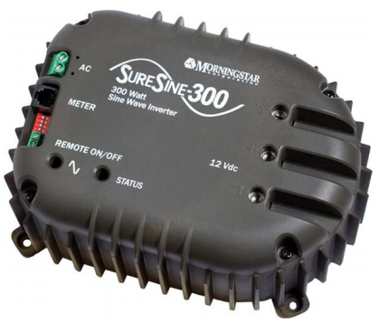
Model number: SI-300-115V-UL (60Hz)
Company: Morningstar
Company Website: https://www.morningstarcorp.com/
Product Page: https://www.morningstarcorp.com/products/suresine/

Details:

Data Communications: RJ-11Connection with Morningstar Meterbus / MODBUS RTU (16-bit)
Continuous Power Rating: 300W @ 25 C
Peak Power Rating (10 minutes): 600W
DC input voltage: 10.0V - 15.5 V
Waveform: Pure Sine Waveform
AC Output Voltage (RMS): 220V or 115V +/- 10%
AC Output Voltage Frequency: 50 or 60 Hz +/- 0.1%
Peak efficiency: 92%
Total Harmonic Distortion (THD): < 4%
Self Consumption:
Inverter On (no load): 450mA
Inverter Off: 25mA
Stand-by: 55mA
Low voltage Disconnect (LVD): 11.5V or 10.5V
Low Voltage Reconnect; 12.6V or 11.6V
LVD Warning Threshold (buzzer): 11.8V or 10.8V
LVD Delay Period: 4 minutes
High voltage disconnect: 15.5V
High Voltage Reconnect: 14.5V
Standby On Threshold: ~8W
Standby Off Threshold: ~8W
High Temperature Disconnect: 95 C (heatsink)
High temperature reconnect; 80 C (heatisnk)

Electronic Protections:

Reverse Polarity (fused)
AC Short Circuit
AC overload
DC Terminals: Max wire size:
– 2.5 to 35 mm^2 / 14 to 2 AWG
Remote On/Off terminals: Max. Wire size:
– 0.25 to 1.0 mm^2 / 24 to 16 AWG
Enclosure: IP20
Cast anodized Aluminum

Physical Characteristics:

Dimensions: 213 x 152 x 105 mm (8.4 x 6.0 x 4.1 in)
Weight: 4.5 Kg/10.0lbs
AC terminals: Max wire size:
– 4 mm^2 / 12AWG

Environmental Protections:

Ambient Operating Temperature: -40 C to +45C
Storage Temperature: -55 C to +85C
Humidity: 100% (non-condensing)
Tropicalization: Conformal coating on PCBs. Epoxy encapsulated transformer and inductors.

Accessories:

3A fuse
100A fuse

GFCI outlet:

Model: 15 Amp Self-Test smartlock pro slim duplex GFCI Outlet, white
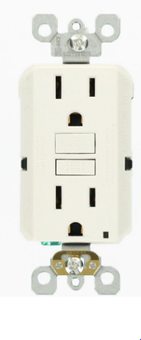
Company: Home Depot
Company Website: https://www.homedepot.com/
Product Page: https://www.homedepot.com/p/Leviton-15-Amp-Self-Test-SmartlockPro-Slim-Duplex-GFCI-Outlet-White-R02-GFNT1-0KW/206001533

GFCI outlet box:

Model: 1-Gang Weather Box While-In-Use cover
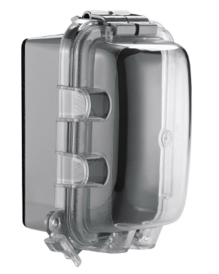
Company: Home Depot
Company Website: https://www.homedepot.com
Product Page: https://www.homedepot.com/p/1-Gang-Weather-Box-While-In-Use-Cover-WIU-1/206469236?cm_mmc=Shopping%7CG%7CVF%7CD27E%7C27-6_CONDUIT-BOXES-FITTINGS%7CNA%7CPLA%7c71700000033099037%7c58700003867178937%7c92700031086148565&gclid=EAIaIQobChMI2PLwrenQ4wIVAf_jBx2q5Q92EAkYASABEgKGrPD_BwE&gclsrc=aw.ds

Recommended Accessories:

RJ-11 Meterbus to USB MODBUS adapter

Model: Morningstar USB MeterBus Adapter > UMC-1
Company: Morningstar
Company Website: https://www.morningstarcorp.com
Product Page: https://solarflexion.com/umc-1?_vsrefdom=adwords&gclid=EAIaIQobChMIs6q9_eTQ4wIVef_jBx3u-AdIEAQYBSABEgKaCPD_BwE

RJ-11 data communications cable

Model: USB Meterbus Adapter
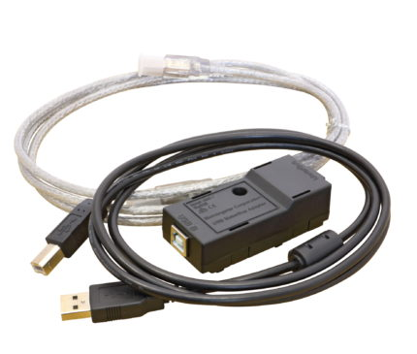
Company: Morningstar
Company Website: https://www.morningstarcorp.com/
Product Page:https://www.morningstarcorp.com/products/usb-meterbus-adapter/

GSM module

Explanation:

I don’t like the FONA module. I would like to replace it. I would like to instead use this GSM/GPRS shield. It slides easily onto the master Raspberry Pi, and can also fit another shield onto it if so desired. I will be fabricating a faculty sensor shield utilizing the I2C protocol. This shield utilizes the UART protocol. The Raspberry Pi can only accommodate 1 use of the UART protocol using the GPIO pins. The others will be using the Virtual COM ports of the Raspberry Pi. The Tristars will be using a RS-232 to USB converters with an FTDI chip installed in them for communication, and the BMS system will be using a split-open USB wire that will connect directly to the BMS control unit.

Name: Raspberry Pi GSM/GPRS Shield
SKU: S13
Company: Sixfab
Company webpage: https://sixfab.com/
Product page: https://sixfab.com/product/gsmgprs-shield/
s
Features:

Fully compatible with Raspberry Pi models that have the 40-pin GPIO header (3, 2, B+, A+, Zero)
High Data Speed: GPRS Multi-slot class 12, 85.6kbps downlink and 85.6kbps uplink data rates
Quad-band: 850/900/1800/1900MHz
Built-in PCB antenna, also there is an external antenna port available
Supported Protocols: TCP/ UDP/ PPP/ FTP/ HTTP/ SMTP/ CMUX/ SSL
Quectel’s QuecLocator Feature, lets you get the location without GPS/GNSS
Extremely low standby power consumption by M66, 1.3mA at DRX=5
Efficient and low quiescent current regulator circuit can hold up to 3.6A
Bluetooth Function, V3.0 specification, SPP and OPP profiles available.
Micro SIM Card socket can easily reachable on the downside of the shield.
Can be used standalone with PC/Laptop over micro USB, without stacking with Raspberry Pi thanks to FTDI chip on the shield.
Sending/Receiving standard V.25ter AT commands over UART port to Raspberry Pi is available
Working temperature range: -30°C to +80°C

SIM card

Explanation:

If we will be sending data with our GSM module, we must have a SIM card to tell the cell phone tower what carrier we are using, and if we have permission to use their cell phone tower. The SIM card only stores 1 piece of data: our ID number. That’s all it does, but it’s very important.

Model: Ting GSM SIM card
Quantity: 1
Carrier: Ting
Company Website: https://ting.com/
Product Page: https://ting.com/shop/gsmSIM

You must register with Ting and pay a monthly fee of $50 for an unlimited 2G service plan.

Web Server

Explanation:

We must have a server to send the data to. I’m sending all my data in JSON format so it’s easier for the website to read it.

In my down time (when I’m too tired to work on electronics), I would like to work on the website.

Crossing the bridge when we get to it.

Host: ucsc.edu
Website link: arboretum-backend.soe.ucsc.edu/
Server Location: ???
Who to call when things go bad: ???
Uptime Percentage: ???
Language Programmed in: ???

